SQL – Joins

customer(custname, custst, custcity)pk
branch(branchname, branchcity, assets)pk
account(acctno, branchname, balance) pk, fk
loan(loanno, branchname, amount) pk, fk

depositor(custname, acctno)fk, fk
borrower(custname, loanno)fk, fk

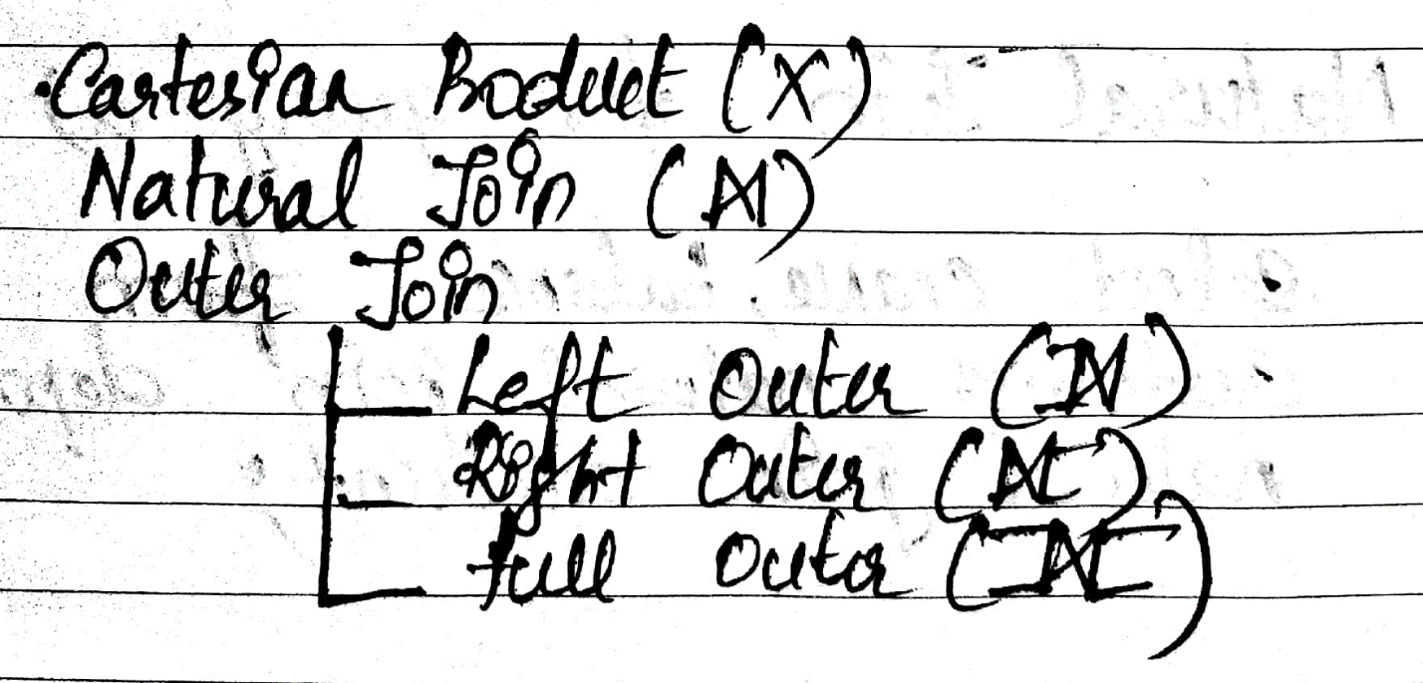
- list the name and the city of the customer – customer
select custname, custcity from customer
- list all account details of chennai city – branch, account
select acctno, branchname, balance from account natural join branch where branchcity=”Chennai”;

$${∏_{acctno, branchname, balance}(σ}_{branchcity="chennai"}(account*branch))$$

- list the customer name with the account details – depositor, account
select custname, acctno, branchname, balance from depositor natural join account;
or
select * from depositor natural join account;

$$∏_{custname, acctno, branchname, balance}(account*depositor)$$
- list the customer name with the acctno and the loanno – depositor, borrower
select * from depositor natural join borrower;
σ(depositor*borrower)

- list the customer name with the acctno, its branchname and the loanno, its branchname – depositor, borrower, loan, account
select d.custname, d.acctno, b.loanno, a.branchname, l.branchname from borrower b, loan l, depositor d, account c where d.acctno=a.acctno and b.loanno=l.loanno;

Customer Relation

SQL> create table customer(custname varchar2(10),custst varchar2(10),custcity varchar2(10),primary key(custname));

Table created.

SQL> desc customer;
Name Null? Type
----------------------------------------- -------- ------------------
CUSTNAME NOT NULL VARCHAR2(10)
CUSTST VARCHAR2(10)
CUSTCITY VARCHAR2(10)

SQL> insert into customer values('&custname','&custst','&custcity');
Enter value for custname: aditya
Enter value for custst: janpath
Enter value for custcity: delhi
old 1: insert into customer values('&custname','&custst','&custcity')
new 1: insert into customer values('aditya','janpath','delhi')

1 row created.

SQL> /
Enter value for custname: pooja
Enter value for custst: avadi
Enter value for custcity: chennai
old 1: insert into customer values('&custname','&custst','&custcity')
new 1: insert into customer values('pooja','avadi','chennai')

1 row created.

SQL> /
Enter value for custname: sai
Enter value for custst: jayanagar
Enter value for custcity: bangalore
old 1: insert into customer values('&custname','&custst','&custcity')
new 1: insert into customer values('sai','jayanagar','bangalore')

1 row created.

SQL> /
Enter value for custname: anaya
Enter value for custst: rajpath
Enter value for custcity: delhi
old 1: insert into customer values('&custname','&custst','&custcity')
new 1: insert into customer values('anaya','rajpath','delhi')

1 row created.

SQL> /
Enter value for custname: seetha
Enter value for custst: park st
Enter value for custcity: bangalore
old 1: insert into customer values('&custname','&custst','&custcity')
new 1: insert into customer values('seetha','park st','bangalore')

1 row created.

SQL> /
Enter value for custname: aryan
Enter value for custst: vandalur
Enter value for custcity: chennai
old 1: insert into customer values('&custname','&custst','&custcity')
new 1: insert into customer values('aryan','vandalur','chennai')

1 row created.

SQL> select * from customer;

CUSTNAME CUSTST CUSTCITY
---------- ---------- ----------
aditya janpath delhi
pooja avadi chennai
sai jayanagar bangalore
anaya rajpath delhi
seetha park st bangalore
aryan vandalur chennai

6 rows selected.

SQL> commit;

Commit complete.

Branch Relation

SQL> create table branch(branchname varchar2(10),branchcity varchar2(10),assets number(10,2), primary key(branchname));

Table created.

SQL> desc branch;
Name Null? Type
----------------------------------------- -------- ------------------
BRANCHNAME NOT NULL VARCHAR2(10)
BRANCHCITY VARCHAR2(10)
ASSETS NUMBER(10,2)

SQL> insert into branch values('&branchname','&branchcity',&assets);
Enter value for branchname: ring road
Enter value for branchcity: delhi
Enter value for assets: 233222
old 1: insert into branch values('&branchname','&branchcity',&assets)
new 1: insert into branch values('ring road','delhi',233222)

1 row created.

SQL> /
Enter value for branchname: anna salai
Enter value for branchcity: chennai
Enter value for assets: 122321
old 1: insert into branch values('&branchname','&branchcity',&assets)
new 1: insert into branch values('anna salai','chennai',122321)

1 row created.

SQL> /
Enter value for branchname: hal
Enter value for branchcity: bangalore
Enter value for assets: 43344
old 1: insert into branch values('&branchname','&branchcity',&assets)
new 1: insert into branch values('hal','bangalore',43344)

1 row created.

SQL> /
Enter value for branchname: vandalur
Enter value for branchcity: chennai
Enter value for assets: 333211
old 1: insert into branch values('&branchname','&branchcity',&assets)
new 1: insert into branch values('vandalur','chennai',333211)

1 row created.

SQL> select * from branch;

BRANCHNAME BRANCHCITY ASSETS
---------- ---------- ----------
ring road delhi 233222
anna salai chennai 122321
hal bangalore 43344
vandalur chennai 333211

SQL> commit;

Commit complete.

Account Relation

SQL> create table account(acctno number(5) primary key,branchname varchar2(10),balance number(10,2),foreign key(branchname) references branch);

Table created.

SQL> desc account;
Name Null? Type
----------------------------------------- -------- ------------------
ACCTNO NOT NULL NUMBER(5)
BRANCHNAME VARCHAR2(10)
BALANCE NUMBER(10,2)

SQL> insert into account values(&acctno,'&branchname',&balance);
Enter value for acctno: 101
Enter value for branchname: anna salai
Enter value for balance: 2332
old 1: insert into account values(&acctno,'&branchname',&balance)
new 1: insert into account values(101,'anna salai',2332)

1 row created.

SQL> /
Enter value for acctno: 102
Enter value for branchname: hal
Enter value for balance: 1221
old 1: insert into account values(&acctno,'&branchname',&balance)
new 1: insert into account values(102,'hal',1221)

1 row created.

SQL> /
Enter value for acctno: 103
Enter value for branchname: vandalur
Enter value for balance: 4433
old 1: insert into account values(&acctno,'&branchname',&balance)
new 1: insert into account values(103,'vandalur',4433)

1 row created.

SQL> /
Enter value for acctno: 104
Enter value for branchname: ring road
Enter value for balance: 5445
old 1: insert into account values(&acctno,'&branchname',&balance)
new 1: insert into account values(104,'ring road',5445)

1 row created.

SQL> /
Enter value for acctno: 105
Enter value for branchname: vandalur
Enter value for balance: 7764
old 1: insert into account values(&acctno,'&branchname',&balance)
new 1: insert into account values(105,'vandalur',7764)

1 row created.

SQL> select * from account;

ACCTNO BRANCHNAME BALANCE
---------- ---------- ----------
101 anna salai 2332
102 hal 1221
103 vandalur 4433
104 ring road 5445
105 vandalur 7764

SQL> commit;

Commit complete.

Loan Relation

SQL> create table loan(loanno number(5) primary key,branchname varchar2(15),amount number(10,2),foreign key(branchname) references branch);

Table created.

SQL> desc loan;
Name Null? Type
----------------------------------------- -------- ------------------
LOANNO NOT NULL NUMBER(5)
BRANCHNAME VARCHAR2(15)
AMOUNT NUMBER(10,2)

SQL> insert into loan values(&loanno,'&branchname',&amount);
Enter value for loanno: 501
Enter value for branchname: hal
Enter value for amount: 300459
old 1: insert into loan values(&loanno,'&branchname',&amount)
new 1: insert into loan values(501,'hal',300459)

1 row created.

SQL> /
Enter value for loanno: 502
Enter value for branchname: ring road
Enter value for amount: 211222
old 1: insert into loan values(&loanno,'&branchname',&amount)
new 1: insert into loan values(502,'ring road',211222)

1 row created.

SQL> /
Enter value for loanno: 503
Enter value for branchname: vandalur
Enter value for amount: 665544
old 1: insert into loan values(&loanno,'&branchname',&amount)
new 1: insert into loan values(503,'vandalur',665544)

1 row created.

SQL> /
Enter value for loanno: 504
Enter value for branchname: vandalur
Enter value for amount: 232221
old 1: insert into loan values(&loanno,'&branchname',&amount)
new 1: insert into loan values(504,'vandalur',232221)

1 row created.

SQL> select * from loan;

LOANNO BRANCHNAME AMOUNT
---------- --------------- ----------
501 hal 300459
502 ring road 211222
503 vandalur 665544
504 vandalur 232221

Depositor Relation [Association between customer and account]

SQL> create table depositor(custname varchar2(10), acctno number(5),foreign key(custname) references customer, foreign key(acctno) references account);

Table created.

SQL> desc depositor;
Name Null? Type
----------------------------------------- -------- ------------------
CUSTNAME VARCHAR2(10)
ACCTNO NUMBER(5)

SQL> insert into depositor values('&custname',&acctno);
Enter value for custname: aditya
Enter value for acctno: 104
old 1: insert into depositor values('&custname',&acctno)
new 1: insert into depositor values('aditya',104)

1 row created.

SQL> /
Enter value for custname: pooja
Enter value for acctno: 105
old 1: insert into depositor values('&custname',&acctno)
new 1: insert into depositor values('pooja',105)

1 row created.

SQL> /
Enter value for custname: sai
Enter value for acctno: 102
old 1: insert into depositor values('&custname',&acctno)
new 1: insert into depositor values('sai',102)

1 row created.

SQL> /
Enter value for custname: anaya
Enter value for acctno: 101
old 1: insert into depositor values('&custname',&acctno)
new 1: insert into depositor values('anaya',101)

1 row created.

SQL> /
Enter value for custname: aryan
Enter value for acctno: 103
old 1: insert into depositor values('&custname',&acctno)
new 1: insert into depositor values('aryan',103)

1 row created.

SQL> select * from depositor;

CUSTNAME ACCTNO
---------- ----------
aditya 104
pooja 105
sai 102
anaya 101
aryan 103

SQL> commit;

Commit complete.

Borrower Relation [Association between customer and loan]

SQL> create table borrower(custname varchar2(15), loanno number(5), foreign key(custname) references customer, foreign key(loanno) references loan);

Table created.

SQL> desc borrower;
Name Null? Type
----------------------------------------- -------- ------------------
CUSTNAME VARCHAR2(15)
LOANNO NUMBER(5)

SQL> insert into borrower values('&custname',&loanno);
Enter value for custname: sai
Enter value for loanno: 501
old 1: insert into borrower values('&custname',&loanno)
new 1: insert into borrower values('sai',501)

1 row created.

SQL> /
Enter value for custname: seetha
Enter value for loanno: 501
old 1: insert into borrower values('&custname',&loanno)
new 1: insert into borrower values('seetha',501)

1 row created.

SQL> /
Enter value for custname: aryan
Enter value for loanno: 504
old 1: insert into borrower values('&custname',&loanno)
new 1: insert into borrower values('aryan',504)

1 row created.

SQL> /
Enter value for custname: aryan
Enter value for loanno: 503
old 1: insert into borrower values('&custname',&loanno)
new 1: insert into borrower values('aryan',503)

1 row created.

SQL> /
Enter value for custname: anaya
Enter value for loanno: 502
old 1: insert into borrower values('&custname',&loanno)
new 1: insert into borrower values('anaya',502)

1 row created.
SQL> select * from borrower;

CUSTNAME LOANNO
--------------- ----------
sai 501
seetha 501
aryan 504
aryan 503
anaya 502

SQL> commit;

Commit complete.

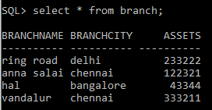 | 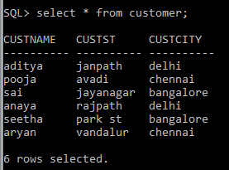
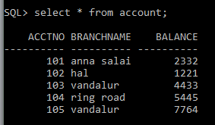 | 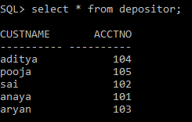
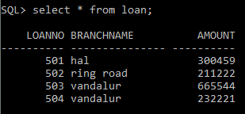 | 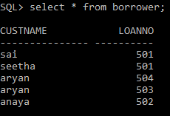

Joins: Joining Customer and Depositor relation

Explicit Inner Join:

SQL> select * from depositor inner join customer on depositor.custname=customer.custname;

CUSTNAME ACCTNO CUSTNAME CUSTST CUSTCITY
---------- ---------- ---------- ---------- ----------
aditya 104 aditya janpath delhi
pooja 105 pooja avadi chennai
sai 102 sai jayanagar bangalore
anaya 101 anaya rajpath delhi
aryan 103 aryan vandalur chennai

Implicit Inner Join and Cartesian product:

SQL> select * from depositor,customer where depositor.custname=customer.custname;

CUSTNAME ACCTNO CUSTNAME CUSTST CUSTCITY
---------- ---------- ---------- ---------- ----------
aditya 104 aditya janpath delhi
pooja 105 pooja avadi chennai
sai 102 sai jayanagar bangalore
anaya 101 anaya rajpath delhi
aryan 103 aryan vandalur chennai

Equi Join [Using Explicit Inner Join]

SQL> select * from depositor inner join customer using (custname);

CUSTNAME ACCTNO CUSTST CUSTCITY
---------- ---------- ---------- ----------
aditya 104 janpath delhi
pooja 105 avadi chennai
sai 102 jayanagar bangalore
anaya 101 rajpath delhi
aryan 103 vandalur Chennai

Non-Equi Join

SQL> select * from depositor a, customer b where a.custname=b.custname;

CUSTNAME ACCTNO CUSTNAME CUSTST CUSTCITY
---------- ---------- ---------- ---------- ----------
aditya 104 aditya janpath delhi
pooja 105 pooja avadi chennai
sai 102 sai jayanagar bangalore
anaya 101 anaya rajpath delhi
aryan 103 aryan vandalur chennai

Natural Join:

SQL> select * from depositor natural join customer;

CUSTNAME ACCTNO CUSTST CUSTCITY
---------- ---------- ---------- ----------
aditya 104 janpath delhi
pooja 105 avadi chennai
sai 102 jayanagar bangalore
anaya 101 rajpath delhi
aryan 103 vandalur Chennai

Cross Join – Without equality constraint

SQL> select * from depositor cross join customer;

CUSTNAME ACCTNO CUSTNAME CUSTST CUSTCITY
---------- ---------- ---------- ---------- ----------
aditya 104 aditya janpath delhi
aditya 104 pooja avadi chennai
aditya 104 sai jayanagar bangalore
aditya 104 anaya rajpath delhi
aditya 104 seetha park st bangalore
aditya 104 aryan vandalur chennai
pooja 105 aditya janpath delhi
pooja 105 pooja avadi chennai
pooja 105 sai jayanagar bangalore
pooja 105 anaya rajpath delhi
pooja 105 seetha park st bangalore

CUSTNAME ACCTNO CUSTNAME CUSTST CUSTCITY
---------- ---------- ---------- ---------- ----------
pooja 105 aryan vandalur chennai
sai 102 aditya janpath delhi
sai 102 pooja avadi chennai
sai 102 sai jayanagar bangalore
sai 102 anaya rajpath delhi
sai 102 seetha park st bangalore
sai 102 aryan vandalur chennai
anaya 101 aditya janpath delhi
anaya 101 pooja avadi chennai
anaya 101 sai jayanagar bangalore
anaya 101 anaya rajpath delhi

CUSTNAME ACCTNO CUSTNAME CUSTST CUSTCITY
---------- ---------- ---------- ---------- ----------
anaya 101 seetha park st bangalore
anaya 101 aryan vandalur chennai
aryan 103 aditya janpath delhi
aryan 103 pooja avadi chennai
aryan 103 sai jayanagar bangalore
aryan 103 anaya rajpath delhi
aryan 103 seetha park st bangalore
aryan 103 aryan vandalur chennai

30 rows selected.

Cross Join – With equality constraint (catesian product or implicit inner join)

SQL> select * from depositor cross join customer where depositor.custname=customer.custname;

CUSTNAME ACCTNO CUSTNAME CUSTST CUSTCITY
---------- ---------- ---------- ---------- ----------
aditya 104 aditya janpath delhi
pooja 105 pooja avadi chennai
sai 102 sai jayanagar bangalore
anaya 101 anaya rajpath delhi
aryan 103 aryan vandalur Chennai

Left Outer Join

SQL> select * from depositor natural left outer join borrower;

CUSTNAME ACCTNO LOANNO
---------- ---------- ----------
sai 102 501
aryan 103 504
aryan 103 503
anaya 101
pooja 105
aditya 104

6 rows selected.

Right Outer Join

SQL> select * from depositor natural right outer join borrower;

CUSTNAME ACCTNO LOANNO
--------------- ---------- ----------
sai 102 501
aryan 103 503
aryan 103 504
seetha 501

Full Outer Join

SQL> select * from depositor natural full outer join borrower;

CUSTNAME ACCTNO LOANNO
--------------- ---------- ----------
aditya 104
pooja 105
sai 102 501
anaya 101
aryan 103 503
aryan 103 504
seetha 501

7 rows selected.

Full Outer Join [Customer, Depositor and Borrower]

SQL> select * from customer natural full outer join depositor natural full outer join borrower;

CUSTNAME CUSTST CUSTCITY ACCTNO LOANNO
--------------- ---------- ---------- ---------- ----------
aditya janpath delhi 104
pooja avadi chennai 105
sai jayanagar bangalore 102 501
seetha park st bangalore 501
aryan vandalur chennai 103 503
aryan vandalur chennai 103 504
anaya rajpath delhi 101

7 rows selected.

Query: List the customers with their account numbers who lives in chennai

Explicit Inner Join:

SQL> select depositor.custname, depositor.acctno from depositor inner join customer on depositor.custname=customer.custname where customer.custcity='chennai';

CUSTNAME ACCTNO
---------- ----------
pooja 105
aryan 103

Implicit Inner Join and Cartesian Product:

SQL> select depositor.custname, depositor.acctno from depositor,customer where depositor.custname=customer.custname and customer.custcity='chennai';

CUSTNAME ACCTNO
---------- ----------
pooja 105
aryan 103

Equi Join [Using Explicit Inner Join]

SQL> select custname, acctno from depositor inner join customer using (custname) where custcity='chennai';

CUSTNAME ACCTNO
---------- ----------
pooja 105
aryan 103

Non-Equi Join

SQL> select a.custname, a.acctno from depositor a,customer b where a.custname=b.custname and b.custcity='chennai';

CUSTNAME ACCTNO
---------- ----------
pooja 105
aryan 103

Natural Join:

SQL> select custname, acctno from depositor natural join customer where custcity='chennai';

CUSTNAME ACCTNO
---------- ----------
pooja 105
aryan 103

Cross Join

SQL> select depositor.custname, depositor.acctno from depositor cross join customer where customer.custname=depositor.custname and custcity='chennai';

CUSTNAME ACCTNO
---------- ----------
pooja 105
aryan 103

Left Outer Join

SQL> select custname, acctno from depositor natural left outer join customer where custcity='chennai';

CUSTNAME ACCTNO
---------- ----------
pooja 105
aryan 103

Right Outer Join

SQL> select custname, acctno from depositor natural right outer join customer where custcity='chennai';

CUSTNAME ACCTNO
---------- ----------
pooja 105
aryan 103

Full Outer Join

SQL> select custname, acctno from depositor natural full outer join customer where custcity='chennai';

CUSTNAME ACCTNO
---------- ----------
pooja 105
aryan 103

